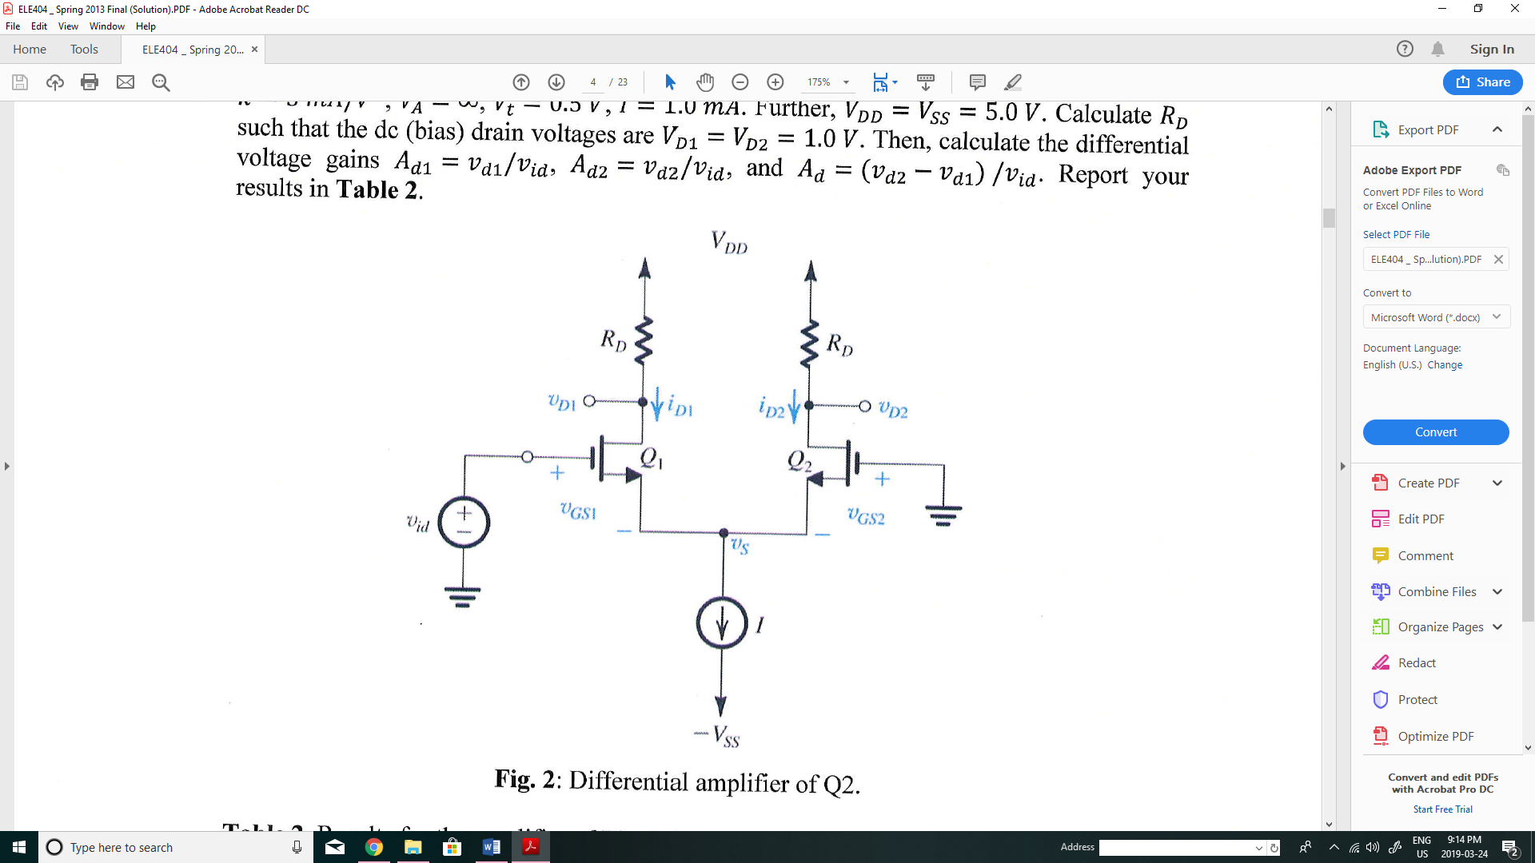Q1. In the differential amplifier shown in figure, the MOS devices are identical and the parameters are: $k=\frac{5mA}{V^{2}}, V_{A}=∞, V_{t}=0.5 V, I=1 mA.$ Further, $V_{DD}=V_{ss}=5.0 V$. Calculate $R_{D}$ such the dc (bias) drain voltages are $V_{D1}=V_{D2}=1.0 V$. Then, calculate the differential voltage gains, $A_{d1}=\frac{v_{d1}}{v_{id}}, A_{d2}=\frac{v_{d2}}{v_{id}},$ and $A_{d}=\frac{v_{d2}-v_{d1}}{v_{id}}.$

Q2. The differential amplifier in figure utilizes a resistor $R_{ss}$ to establish a 1 mA dc bias current. Note that this amplifier uses a single 5-V supply and thus the dc common mode voltage $V_{CM}$ cannot be zero. Transistors $Q_{1}$ and $Q_{2}$ have $k_{n}=2.5 mA/V^{2}$, $V_{t}=0.7 V$ and $λ=0$.

1. 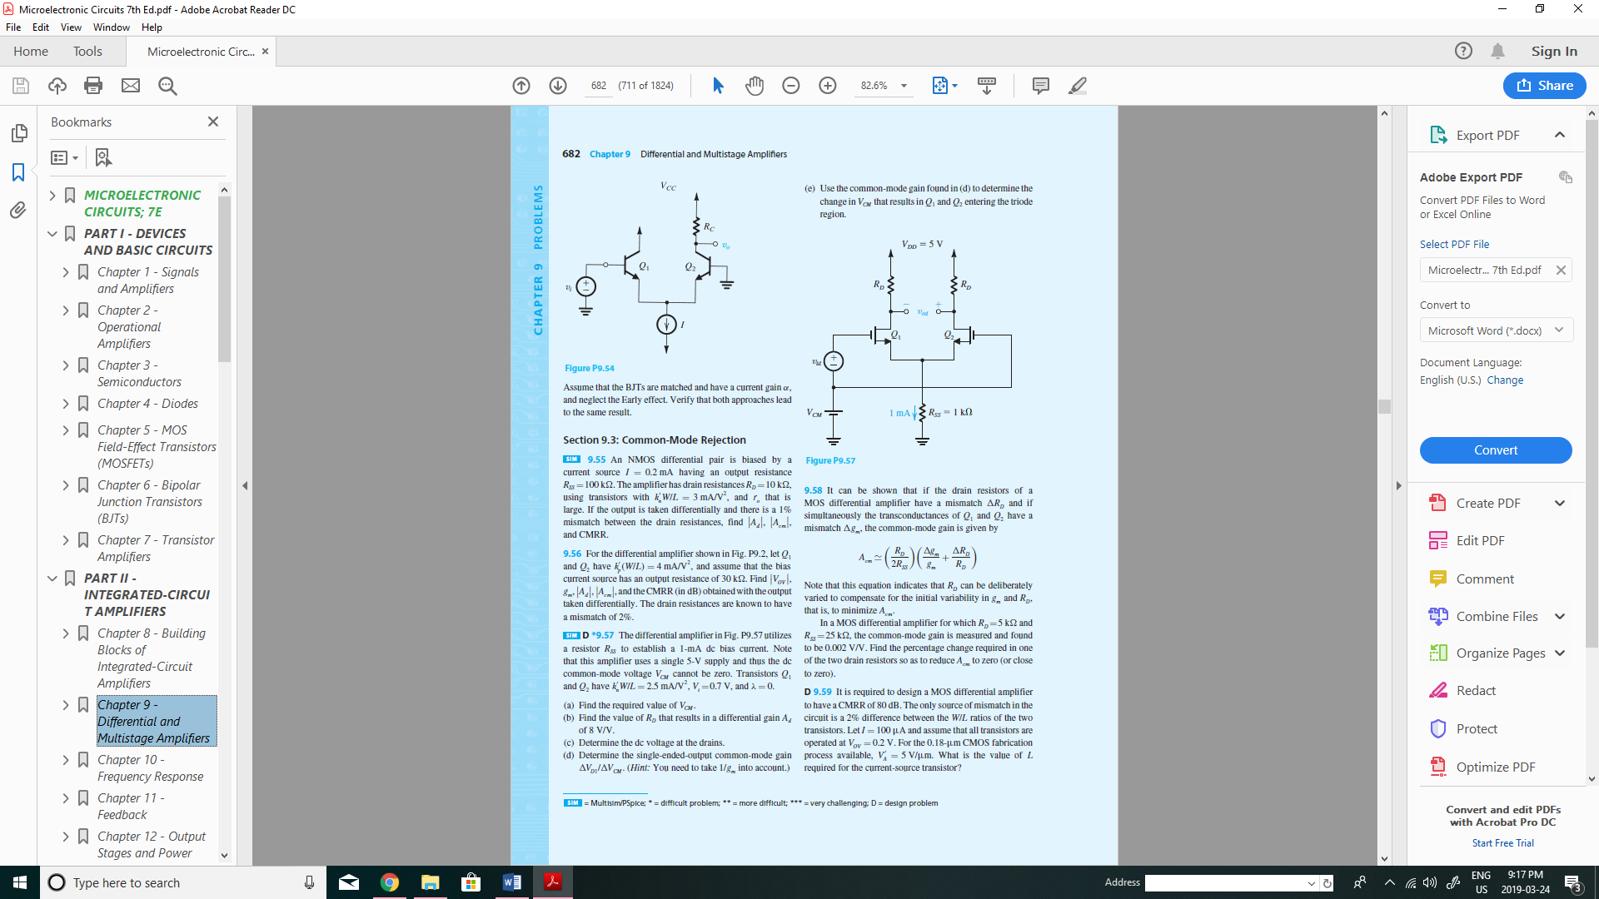Find the required value of $V_{CM}$.
2. Find the value of $R_{D}$ that results in a differential gain $A_{d}=8\frac{V}{V}.$
3. Determine the dc voltage at the drains.
4. Determine the single-ended-output common-mode gain ${Δv_{D1}}/{Δv_{CM}}$.
5. Calculate CMMR in dB.
6. Use the common-mode gain found in (d) to determine the change in $V_{CM}$ that results in $Q_{1}$ and $Q_{2}$ entering the triode mode.

Q3. A MOS differential amplifier is operated at a total current of 0.8 mA using transistor with a W/L ratio of 100, $μ_{n}C_{ox}=0.2\frac{mA}{V^{2}}, V_{A}=20V,$ and $R_{D}=5KΩ$. Find $V_{OV}, g_{m}, r_{o}$ and $A_{d}$.

Q4. The differential amplifier in figure uses transistors with $β=100.$ Evaluate the following.

1. The input differential resistance, $R_{id}$.
2. 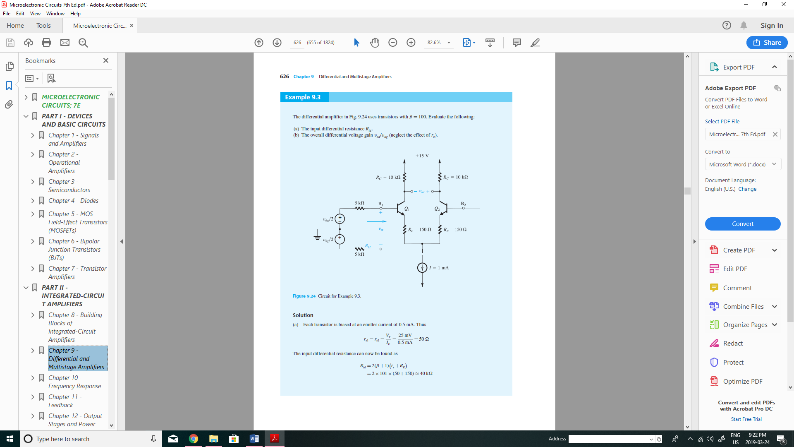The overall differential voltage gain $\frac{v_{od}}{v_{sig}}$ (neglect the effect of $r_{o}$).

Q5. An NMOS differential amplifier employing equal drain resistance of $47kΩ$ has differential gain of $A_{d}$ of 20 V/V.

1. What is the value of $g_{m}$ for each of the two transistors?
2. In each of the two transistors is operating at an overdrive voltage $V_{OV}=0.2$, what must the value of $I$ be?
3. For $v_{id}=0$, what is the dc voltage across each $R_{D}$?
4. If $v_{id}$ is 20mV peak-to-peak sine wave applied in a balanced manner but superimposed on $v_{cm}=0.5V$, what is the peak of the sine wave signal at each drain?
5. What is the lowest value that $V_{DD}$ must have to ensure saturation-mode operation for $Q_{1}$ and $Q_{2}$ at all times? Assume $V_{t}=0.5 V.$